Design Patterns and Principles

Exercise 1: Implementing the Singleton Pattern

- Code:
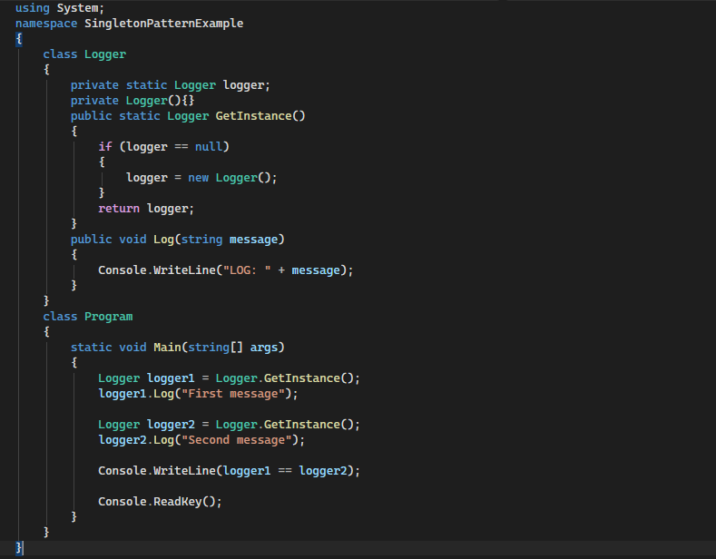
- Output:
- 
Exercise 2: Implementing the Factory Method Pattern

- Code:
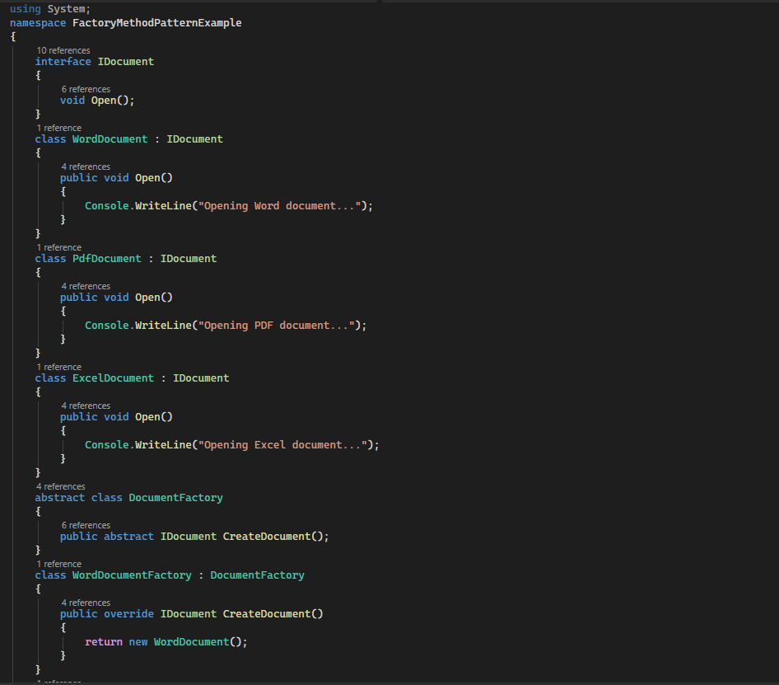
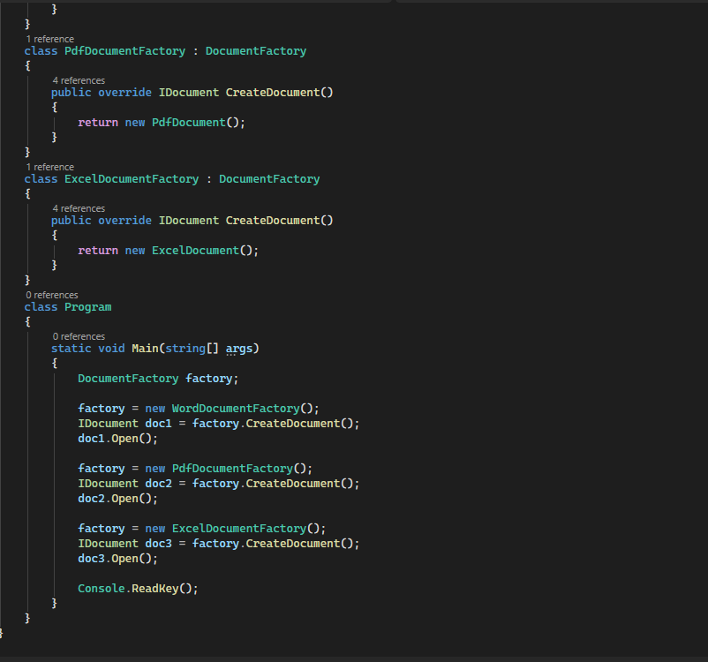
Output:


